CSA1708-ARTIFICIAL INTELLIGENCE
LAB EXPERIMENTS
Program 11 : Python Program for Map Coloring to Implement CSP
Aim
To develop a Python program to solve the Map Coloring Problem using Constraint Satisfaction Problem (CSP) backtracking search so that no two adjacent regions share the same color.
Algorithm
1. Define the set of variables representing regions on the map (e.g., WA, NT, SA, Q, NSW, V, T).
2. Define the domain of allowable colors for each region (e.g., Red, Green, Blue).
3. Define adjacency constraints specifying that neighboring regions cannot be assigned the same color.
4. Initialize an empty assignment dictionary to store color assignments for regions.
5. Define a recursive backtracking function to assign colors to unassigned regions:
6. a. If all regions have been assigned valid colors, return the complete assignment.
7. b. Select the next unassigned region.
8. c. For each color in the domain:
9. i. Check if assigning the color to the region satisfies all neighbor constraints.
10. ii. If consistent, assign the color to the region and recursively invoke search for remaining regions.
11. iii. If the recursive call succeeds, return True.
12. iv. Otherwise, backtrack by removing the assigned color from the region.
13. If all colors for the current region are exhausted without success, return False to trigger backtracking.
14. Display the final consistent color assignment for all regions on the map.

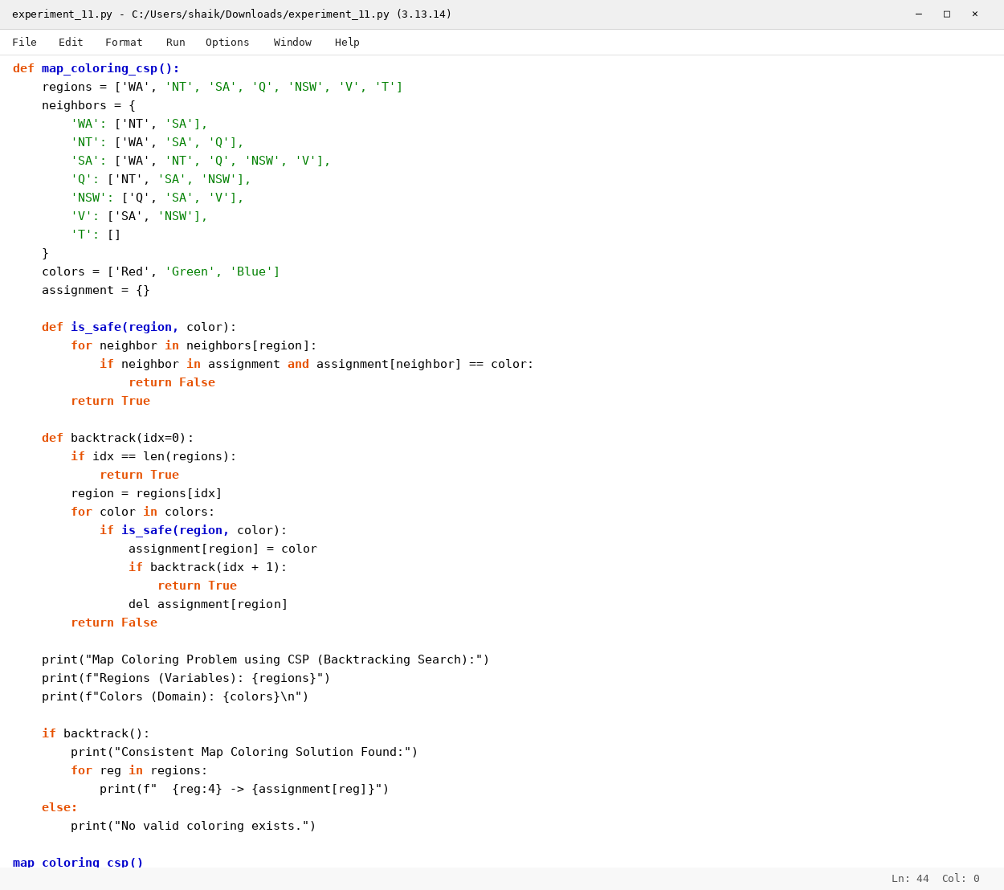

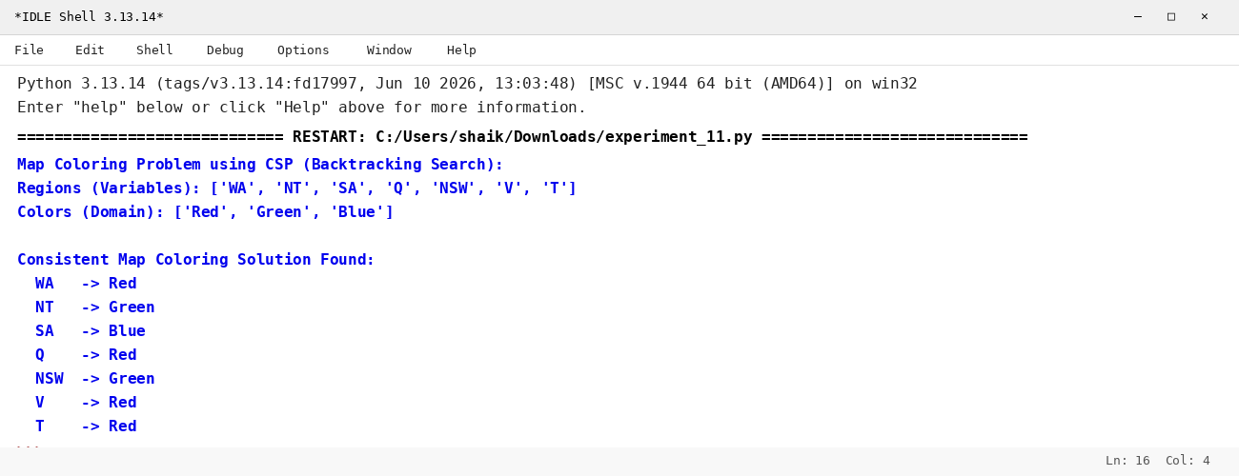

RESULT
Thus, the Map Coloring Problem using CSP was solved successfully using Python.

